Donation Form | 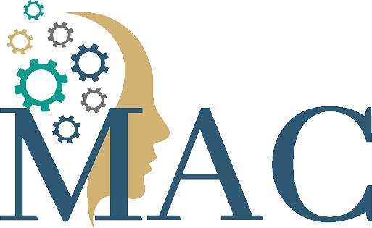

Consider a monetary gift to support our ongoing programming and services provided to children, youth and families affected by Autism Spectrum Disorder (ASD).

Donor Information
BUSINESS NAME IF APPLICABLE | NAME (LAST, FIRST, M.I.)
STREET ADDRESS | EMAIL
CITY, STATE, ZIP | PHONE
Please list as anonymous: YES OR NO | Opt in for emails: YES OR NO

Donation Description
CHECK ONE: CASH PRODUCT / ITEM OTHER
AMOUNT / DESCRIPTION | DATE
NOTES

Contact Information
MAC  Minnesota Autism Center  5860 Baker Road  Minnetonka, MN 55345  www.mnautism.org | Questions?  Contact Sarah Driever  Director of Development  Phone: 952-767 4203  Email: sarah.driever@mnautism.org  We accept gifts of stock, real estate, employee matches and more, and if you have questions about giving through these vehicles, please contact Sarah!
Mail to: Minnesota Autism Center, 5860 Baker Road, Minnetonka, MN 55345. The Minnesota Autism Center is a 501(c)(3) non-profit organization registered in the State of Minnesota. Charitable contributions may be tax deductible, please consult your tax professional.

